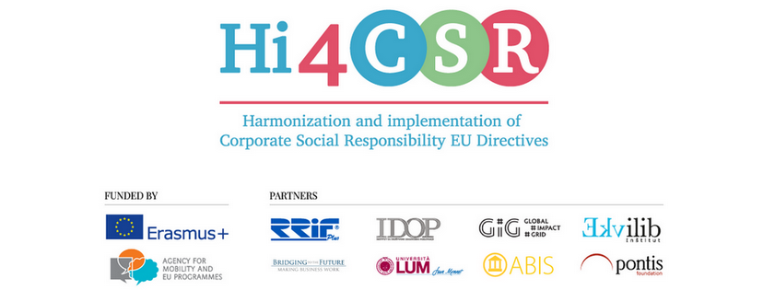
January 29th 2018
PRESS RELEASE
Find out more about CSR and sustainability topics
Erasmus+ project under the name Hi4CSR (Harmonization and implementation of EU CSR Directives) started in October 2016 and will last until April of 2018. It is a transeuropean project established by eight European organizations renowned in the field of CSR - RRiF-plus Ltd. (Croatia), The Croatian Institute for CSR – IDOP (Croatia), Abis – The Academy of Business in Society (Belgium), Ekvilib Institute (Slovenia), Global Impact Grid (Germany), LUM University (Italy), Pontis Foundation (Slovakia) and Bridging to the Future (United Kingdom).
Main objectives of the project are adult education, exchange of good practice and development of the first CSR Guide covering topics of non-financial reporting, eco labelling, water framework directive, circular economy, food donations and the employment of people with disabilities.
January was spent researching project topics and publishing a lot of new articles on corporate social responsibility and sustainability. They cover a range of topics such as new European legislation in the field of CSR, rise of social enterprises in Europe, changes in the workplace and tackling food waste around the world, which can be found below:
- How are Member States implementing the EU Directive on Non-Financial Information
- New European regulation on food donation
- New European waste legislation
- EU Accessibility Act will make products and services more accessible to persons with disabilities
- The Rise of Social Enterprises in Europe: Act Konto
- Companies with top CSR reputation in 2017
- Freewa: social impact start-up is mapping free drinking water
- Respect in the workplace must be a paramount priority
- Women and Successful Business Go Well Together
- Tinder for food: An App for sharing leftovers
- Tackling food waste around the world
- Bread Houses Network
You can find additional information about the project on the www.hi4csr.com website, write to the consortium at info@hi4csr.com or connect through our social media pages: Facebook, Twitter, LinkedIn and YouTube channel

