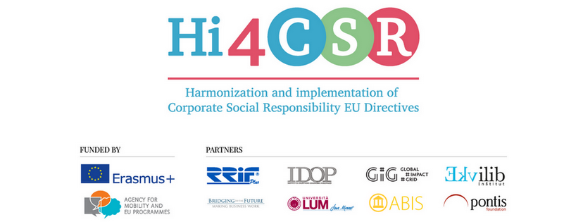
30th of June 2017
PRESS RELEASE
Hi4CSR project invites you to find out more about transformative accounting, diversity in the workplace and sustainable innovation

Erasmus+ project under the name Harmonization and implementation of EU CSR Directives – Hi4CSR began in October 2016 and will last until April of 2018. It is a transeuropean project established by several European organizations renowned in the field of CSR - RRiF-plus Ltd. (Croatia), The Croatian Institute for CSR – IDOP (Croatia), Abis – The Academy of Business in Society (Belgium), Ekvilib Institute (Slovenia), Global Impact Grid (Germany), LUM University (Italy), Pontis Foundation (Slovakia) and Bridging to the Future (United Kingdom).
Main objectives of the project are adult education, exchange of examples of good practice between project partners regarding harmonization and implementation of EU Directives as well as development of the first CSR Guide which will cover topics ranging from non-financial reporting, eco labelling, water framework, food donations and the employment of people with disabilities, to innovation and waste management.
During June, Hi4CSR project partners have researched a number of topics, with a special focus on taxes in the context of CSR and transformative accounting, diversity in the workplace, sustainable innovation and new developments within the EU regarding the issue of food waste, all of which you can find below:
- Building a transformative accounting
- Taxes: a CSR issue often neglected
- Do you still think that ESG is voluntary?
- How the ABIS member Johnson and Johnson is creating a new vision of health with its Citizenship & Sustainability 2020 Goals
- First Sixteen Companies Signed the Diversity Charter Slovakia
- European Parliament proposal for cutting food waste
- CityTree, an intelligent air filter for cities

You can find additional information about the project on the www.hi4csr.com website, write to the consortium at info@hi4csr.com or connect through our social media pages: Facebook, Twitter, and LinkedIn as well as through our brand new YouTube channel featuring a video on 2nd Hi4CSR Learning Activity which took place last month in Berlin.

