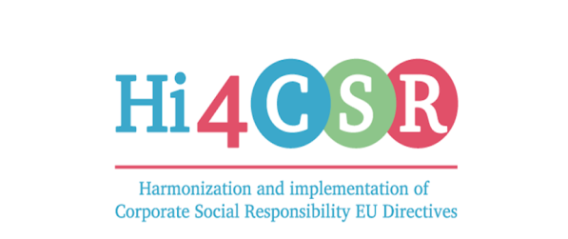 1. TPM, October 14th 2016
Ljubljana, Slovenia

AGENDA

12:45 – 13:30 PRESENTING PROJECT PARTNERS
13:30 – 14:15 PRESENTING THE PROJECT
14:15 – 15:00 FINANCES
15:00 – 16:00 LUNCH / SOCIAL ENT. SKUHNA
AFTER LUNCH:
16:00 – DISCUSSING PHASES OF THE PROJECT
MISCELLANEOUS
LJUBLJANA SIGHTSEEING

